In Wire-Bonding Ultrasonic Welding is used to attach a wire to a metal plate to allow electric contact. In this process the factors, Power, Time, Pressure and LoopValue are varied in order to investigate how these effect the quality characteristics, Heel-Cracks, Liftoff and WireTear. The responses represent damage profiles that can occur when the bond is tested. The values are collected after applying a certain very strong force and checking which type of damage occurs.

- Heel Crack, HC, means there was so much energy in the process that at the heel of the bond there is damage.

- Lift-Off, LO, means that there was too little energy and the bond did not hold at all, the wire just lifted off the plate easily.

- WireTear, WT, means that the bond is so strong, that the wire tears at a completely different place that has nothing to do with the bond.

The data table consists of 24 rows, in which the 4 parameters were varied and the results were recorded in the form of relative frequencies of the respective damage profiles that have occurred.

Task 1:

Import the data into R.

Please fit linear models for the three responses.

Which of the four factors are statistically significant at 95%-Confidence level?

How well do the statements above correspond to the signs of the coefficients?

For all 3 responses plot residuals against all 4 factors to decide which ones would need to be modelled by a square term of the form bjjxj (fill in table below, left)?

Square terms recommended from residual analysis? yes/no

Task 2:

Add square terms for all factors to the models of all responses. Then check the significance of the

square terms in the model and this time fill out the table at the bottom:

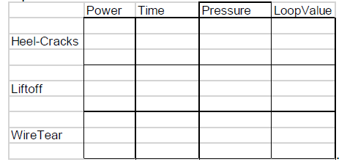

Square terms are significant at 95% confidence level in model.

For all 3 responses plot residuals against fitted values.

For which responses do you consider a transformation to be necessary and why?

Try the transformation. Interpret the error message. What’s the problem?

Task 3 (difficult) – do either this task or task 4

What could be done to avoid the error messages – three possibilities?

Try to see if one of them works?

Redo the residual analysis and report on what is has improved.

Task 4 (alternative) – do either this task or task 3

Make a contingency table from the data for Power and Heel-Crack, such that for Power, low corresponds to 80 and 100, high to 120 and 140, and (leave out the runs with Power = 110), for Heel-Crack low is below s=0.2 and high is above s=0.2.

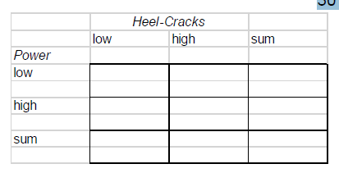

For this contingency table do the Fisher test to check for significance.

Determine sensitivity and specificity.

Change the cutting point s for Heel-Crack to 0.1, 0.2, (as above) 0.3 and 0.4 and draw a rudimentary

ROC-curve (receiver operations characteristic).